Name: |  | Mobile:
SID: |  | Degree:
Car rego no: |  | Make:  e.g Toyota
Model:  e.g Echo |  | Colour:

Terms and Conditions
I understand that if I purchase a space, I will pay a flat rate fee to ACPE of $250.00 per semester
I am a current card holder; I will pay a flat rate fee to ACPE of $225.00 per semester (please write pass number of current card __________

I understand that the fee is non-refundable whether I use the space or not.

P5 parking pass holders will only be given access to P5 car park Monday – Friday 6am – 8pm. Parking outside of these hours will require additional fees.

I understand that if allocated a permit it is for the whole semester. There is no daily, weekly or monthly or part semester parking.

I understand that I must report lost or stolen cards immediately. Replacement cards will incur a further fee of $25.00.

I will abide by all regulations, by laws and other directions that the managing agents, Secure Parking, may impose. Any improper behaviour will result in revocation of the right to park at the P5 facility without recourse.

I have read the terms and conditions and agree to abide by them.
Signature: |  | Date:

METHOD OF PAYMENT: |  |  | CASH |  | CREDIT CARD |  | DIRECT DEPOSIT
 |  |  | (In person only) |  | (In person only) |  | (Bank transfer)

NB. CREDIT CARD PURCHASES TO BE MADE IN PERSON ONLY

DIRECT BANK DEPOSIT:

ACCOUNT NAME: ACPE Pty. Ltd.

BSB: 082 902 (NAB)

ACCOUNT NUMBER: 566 255 467

**Please use Student ID number as reference.

NB. If paying by direct deposit please include copy of screenshot for proof of successful payment.

This form may be lodged in person at ACPE Sydney Olympic Park Reception or via email studentservices@acpe.edu.au.

Office Use Only
Pass No: |  | Semester:
Date Issued: |  | Card Return:
Comments:

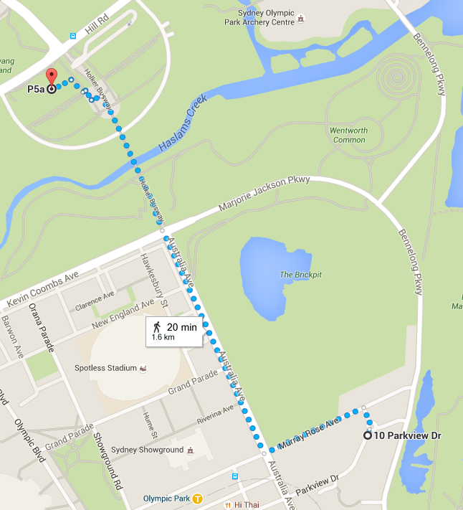
P5
ACPE
15mins walk

